Don’t Miss
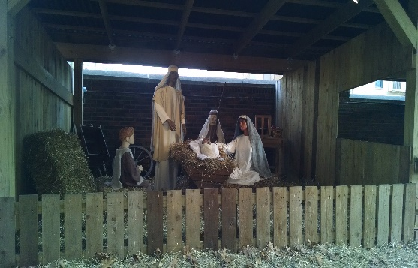
A Franciscan Christmas
A Live Nativity
In the courtyard
Next to the church.
Starting November 25, 2022
Open daily, 1:00 PM until 7:00 PM until January 6.

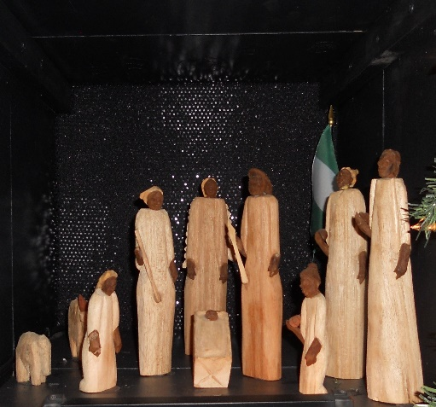
100 Nativities
From around the world and other Christmas displays in the church.
Starting November 25, 2022 open
Fridays 4:00 PM—7:00 PM
Saturdays Noon—7:00 PM
Sundays Noon—5:00 PM
Until January 6.
St. Francis Seraph Church/ School * Corner of Liberty and Vine Street * Over-the-Rhine
Free Parking behind the School * 14 East Liberty Street

